**Title Template Research Article**

Name Author1 and Name Author2

1Department, Faculty, University

2Department, Faculty, University

e-mail: Author’s email

**Abstract**

Abstract is a short information of the paper including background, objective, methodology, result and conclusion of the study.

**Keywords:** 4 words

**1. Introduction**

Introduction tells the important of the topic or the problems that draw to the study. The introduction can include the research objectives, hypothesis or literature Review of the study.

**2. Research Methodology**

Research Methodology includes the materials, tools and method of the study. Also, the research methodology should have the detail of the study, the study analysis and the clear and short process of the study.

**3. Research Results**

Research Results tell the clear result of the study. The detail of this part can be included chart, figure, table, etc.

3.1 Table

The table must have the number and title of table. (Table 1)

**Table 1:** Clear line drawings are essential.

|  |  |  |  |  |  |
| --- | --- | --- | --- | --- | --- |
| Roof form | Orientation | | Tilted angle | | |
| 15 | 30 | 60 |
| Gable  gable | E-W | gable-w | • | • | • |
| N-S | gable-n | • | • | • |
| Hip  hip | E-W | hip-w | • | • | • |
| N-S | hip-n | • | • | • |
| Flat Slab  flat |  | flat-w |  | | |

3.2 Figure

The figure must have the number and title of the figure (figure 1)

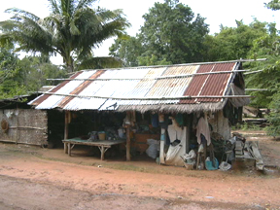

**Figure 1:** Temporary Shelter from surveys.

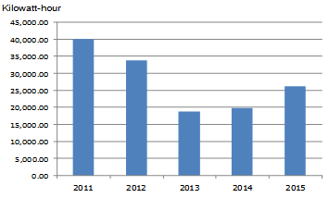

**Figure 2:** Energy Consumption.

3.3 Equation

The equation must be on the center of the page with the number of each equation.

 (1)

Where,

= irradiance from direct sun radiation the tilted roof surface

 = the solar normal radiation

= the angle of incidence of the sun rays onto the roof surface

**4. Conclusion and Discussion**

The Conclusion and Discussion can be included the study results with the analysis by referencing principle or theory. This part can includes suggestion for future study.

**5. Acknowledgement**

Acknowledgement is a short information of the funding for this study.

**6. Reference**

References should not appear as footnotes but should be gathered together at the end of the text. References should be numbered and cited like, [1], [2-3], [1,4], etc.

[1] N. Baker and K. Steemers, *Daylight Design of Buildings*. London: James & James, 2001.

[2] C. Carter and J. De Villiers, *Principles of Passive Solar Building Design*. Oxford: Pergamon Press, 1987.

[3] H. J. Cowan, Ed., *Solar Energy Applications in the Design of Buildings*. London: Applied Science Publishers, 1980.

[4] T. Banerjee and M. Southworth, Eds., *City Sense and City Design Writings and Projects of Kevin Lynch*. Cambridge: MIT Press, 1990.

[5] J. F. Halldane, "Lighting basics in Asia: Realities of the building-in-use," in *2nd Lux Pacifica Lighting Conference*, Bangkok, Thailand, 1993, pp. C32-C40.

[6] D. M. Wilkinson, "Light attenuation by Lime and selection pressures on woodland spring flowers," *Quaternary Newsletter,* vol. 67, pp. 47-50, 1992.

[7] H. C. Weston, "Rationally recommended illumination levels," *Transactions of the Illuminating Engineering Society (London),* vol. 26, pp. 1-16, 1961.

[8] The Illuminating Engineering Society of North America (IES). (2016, 11 October). *The Illuminating Engineering Society of North America (IES)*. Available: <http://www.ies.org>